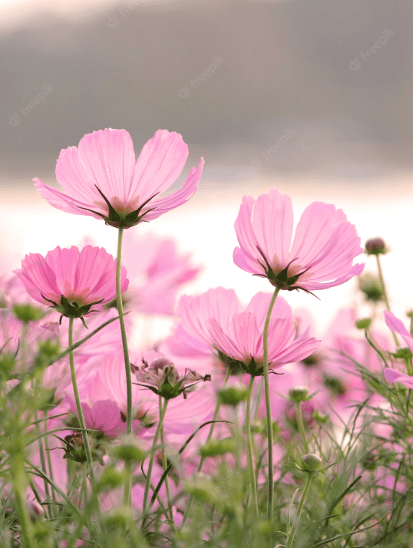
Poems About Nature
There’s a world of wonder all around us every day. From the biggest clouds in the sky to the tiniest dew drops, poets have been inspired throughout the ages. In the hustle and bustle of our daily lives, it’s easy to take our surroundings for granted. Here are some poems about nature to encourage us to stop and appreciate the beauty around us.
Quick reminder: Poetry is about self-expression, so please review the poems about nature before sharing them with students to ensure that the authors’ work matches the tone of your classroom.


Project Summary
This famous narrative poem transforms an ordinary moment into a gripping story about the moment when the Hunter meets the Hunted. The fisherwoman's catch of a tremendous fish takes an unexpected diversion when she takes the opportunity to observe it at close range. The life story of The Fish as told by its battle scars and beautiful fishiness gives the encounter a personal side and result in things taking an unexpected turn.
I caught a tremendous fish
and held him beside the boat
half out of water, with my hook
fast in a corner of his mouth.
He didn’t fight.
He hadn’t fought at all.
He hung a grunting weight,
battered and venerable
and homely. Here and there
his brown skin hung in strips
like ancient wallpaper,
and its pattern of darker brown
was like wallpaper:
shapes like full-blown roses
stained and lost through age.
He was speckled with barnacles,
fine rosettes of lime,
and infested
flowers.png

flowers_1.png

 | Team |  | Autumn wind chases in  From all directions  And a thousand chaste leaves  Give way.  Scatter in me the seeds  Of a thousand saplings.  Let grow a grassy heaven.  On my brow: a sun.  This bliss is yours, Living  World, and alone it endures.  Music at midnight.  Young wine.  Lovers hand in hand  By daylight, moonlight.  Living World, hold me  In your mouth,  Slip on your frivolous shoes  And dance with me. My soul  Is the wild vine  Who alone has grasped it,  Who has seen through the awful plot,  Who will arrive in time to vanquish  The river already heavy with blossoms,  The moon spilling light onto packs  Of men. What is sadder than witless  Wolves, wind without borders,  Nationless birds, small gifts  Laden with love’s intentions?

 |  | Jefferson Vance  Editor | BARBARA KINGSOLVER, THE POISONWOOD BIBLE  “Mama BekwaTataba stood watching us—a little jet-black woman. Her elbows stuck out like wings, and a huge white enameled tub occupied the space above her head, somewhat miraculously holding steady while her head moved in quick jerks to the right and left.”
 |  | Aaliyah Fitzgerald  Creator | JOHN KENNEDY TOOLE, A CONFEDERACY OF DUNCES  “A green hunting cap squeezed the top of the fleshy balloon of a head. The green earflaps, full of large ears and uncut hair and the fine bristles that grew in the ears themselves, stuck out on either side like turn signals indicating two directions at once. Full, pursed lips protruded beneath the bushy black moustache and, at their corners, sank into little folds filled with disapproval and potato chip crumbs. In the shadow under the green visor of the cap Ignatius J. Reilly’s supercilious blue and yellow eyes looked down upon the other people waiting under the clock at the D.H. Holmes department store, studying the crowd of people for signs of bad taste in dress. Several of the outfits, Ignatius noticed, were new enough and expensive enough to be properly considered offenses against taste and decency. Possession of anything new or expensive only reflected a person’s lack of theology and geometry; it could even cast doubts upon one’s soul.”
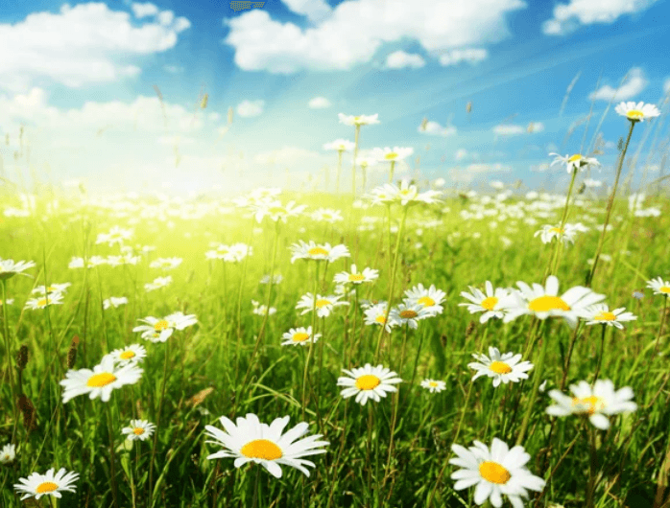 |  | erfd  dsf | sfd
 |  | Joshu  dfg | dfsdf  dsfsd

Business Model Canvas
On one lovely evening, a young boy was laughing and playing in the garden. He was chasing butterflies as he ran across the beautiful flowers. He also saw a bulky cow who was trying to keep a bug away by swirling her tail. The boy saw different animals like frogs, fish, etc. The child laughed and enjoyed the whole scene a lot. He then saw a small brown squirrel running here and there, he tried to follow it and reached a flower bed. It had beautiful red roses, the boy tried to pick one flower but the thorns plugged his finger. He ran to his mother crying and told her about everything. Listening to this his mother explained that we must not put any sort of harm to nature instead we should help it to grow. The boy learned a new lesson and was very happy.


Testing
The moral of this beautiful story is that we humans must understand and value our nature. We should not exploit it blindly. The life of each and every living being on this earth matters, so we must let them live and not interfere or destroy them for our own sake. We may satisfy ourselves by exploiting nature's present, but it will definitely harm us in the near future. As it is said, "one shall reap what it sows". This is the lesson of the nature short story.
Test Type
Homepage
BMC Blocks Test
 |  |  |  |  |  |  | Status |  | Incomplete

Assumption
New
Test Plan

Test Result

Test Type
Interview
BMC Blocks Test
  VP | CR | CH | KA
   |  |  |  |  |  |  | Status |  | Incomplete
Assumption
Test Assupmtions HomepageTest Assupmtions HomepageTest Assupmtions Homepage
Test Plan
Test Assupmtions HomepageTest Assupmtions HomepageTest Assupmtions Homepage
Test Result

Test Type
Prototype
BMC Blocks Test
  CS | VP | CR | CH | KP | KA | KR
   |  |  |  |  |  |  | Status |  | Unsure
Assumption
Test Assupmtions HomepageTest Assupmtions Homepage
Test Plan
Test Assupmtions HomepageTest Assupmtions HomepageTest Assupmtions HomepageTest Assupmtions Homepage
Test Result

Test Type
Prototype
BMC Blocks Test
  CR | KA | RE | SU | CO
   |  |  |  |  |  |  | Status |  | Invalid
Assumption
Test Assupmtions HomepageTest Assupmtions HomepageTest Assupmtions Homepage
Test Plan
Test Assupmtions HomepageTest Assupmtions HomepageTest Assupmtions Homepage
Test Result

Test Type
Prototype
BMC Blocks Test
  VP | CR | CH | KP | KA | KR
   |  |  |  |  |  |  | Status |  | Invalid
Assumption
Test Assupmtions HomepageTest Assupmtions Homepage
Test Plan
Test Assupmtions HomepageTest Assupmtions Homepage
Test Result

Test Type
Homepage
BMC Blocks Test
 |  |  |  |  |  |  | Status |  | Incomplete

Assumption
Test Assupmtions HomepageTest Assupmtions HomepageTest Assupmtions Homepage
Test Plan

Test Result

Test Type
Research
BMC Blocks Test
 |  |  |  |  |  |  | Status |  | Invalid

Assumption
Test Assupmtions HomepageTest Assupmtions Homepage
Test Plan
Test Assupmtions HomepageTest Assupmtions HomepageTest Assupmtions Homepage
Test Result

Test Type
Homepage
BMC Blocks Test
 |  |  |  |  |  |  | Status |  | Incomplete

Assumption
Test Assupmtions HomepageTest Assupmtions HomepageTest Assupmtions HomepageTest Assupmtions HomepageTest Assupmtions HomepageTest Assupmtions Homepage
Test Plan

Test Result

Test Type
Research
BMC Blocks Test
 |  |  |  |  |  |  | Status |  | Incomplete

Assumption

Test Plan
What is your assumption?
Define the assumption you want to test.What is your assumption?
Define the assumption you want to test.
Test Result

 | Desirability |  | The Nature Story  On one splendid evening, when the weather was very pleasant, a boy was playing in the garden. He was running left and right after some beautiful butterflies. He looked around and saw colorful flowers of all shapes and sizes. He then saw a shiny green frog hopping around, he ran after it and reached near a small pond. He saw small golden fishes in the pond. Near the pond, he saw a big black and white cow calmy chewing green grass. The boy noticed a little bug teasing the cow. The cow then swirled its tail back and forth to keep the bug away. Looking at it the boy laughed loudly and said "Wow! Nature is so amazing. It has the power to attract anyone to itself." Suddenly he saw a notorious little squirrel running here and there, he chased after it and reached near a flower bed. The flower bed had beautiful red roses that smelled wonderful. Looking at the rose the boy tried to pick them and got plugged by a thorn. His finger began to bleed and he felt unbearable pain. He immediately ran to his mother crying. The mother asked him" What happened? why are you crying so loudly".

Customer Segment
We, humans, are so engaged in our life and recreation that we cut trees blindly, a survey states that around 27,000 trees are cut down each day on earth. Which makes it to 9,855,000 trees in a single year. Even making a single notebook of paper requires around 2-3 average trees. It is also seen that each year the level of oxygen decreases by 0.2 percent, due to the cutting down of trees.
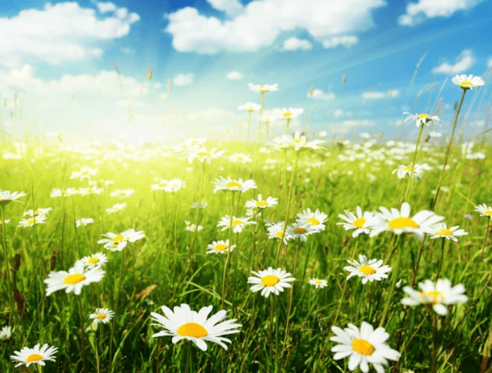
  Title test
  Age range  18 - 60 | Type of Segment  B2cCustomerSegment
  Description
  Nature stories are one of the best stories to tell to your kids during bedtime or while having a walk in the garden. Parents should often take their kids to parks, gardens, or outings in nature. This helps them in bonding with nature at a young age. This would make them feel affectionate toward nature, and they may never harm them.
  What are their goals?
  Nature stories are one of the best stories to tell to your kids during bedtime or while having a walk in the garden. Parents should often take their kids to parks, gardens, or outings in nature. This helps them in bonding with nature at a young age. This would make them feel affectionate toward nature, and they may never harm them.
  What frustrates them?
  Nature stories are one of the best stories to tell to your kids during bedtime or while having a walk in the garden. Parents should often take their kids to parks, gardens, or outings in nature. This helps them in bonding with nature at a young age. This would make them feel affectionate toward nature, and they may never harm them.
  What problem are you solving for them?
  Nature stories are one of the best stories to tell to your kids during bedtime or while having a walk in the garden. Parents should often take their kids to parks, gardens, or outings in nature. This helps them in bonding with nature at a young age. This would make them feel affectionate toward nature, and they may never harm them.

 | Value Proposition
Nature stories are one of the best stories to tell to your kids during bedtime or while having a walk in the garden. Parents should often take their kids to parks, gardens, or outings in nature. This helps them in bonding with nature at a young age. This would make them feel affectionate toward nature, and they may never harm them.
Nature stories are one of the best stories to tell to your kids during bedtime or while having a walk in the garden. Parents should often take their kids to parks, gardens, or outings in nature. This helps them in bonding with nature at a young age. This would make them feel affectionate toward nature, and they may never harm them.
Nature stories are one of the best stories to tell to your kids during bedtime or while having a walk in the garden. Parents should often take their kids to parks, gardens, or outings in nature. This helps them in bonding with nature at a young age. This would make them feel affectionate toward nature, and they may never harm them.
 |  |  | 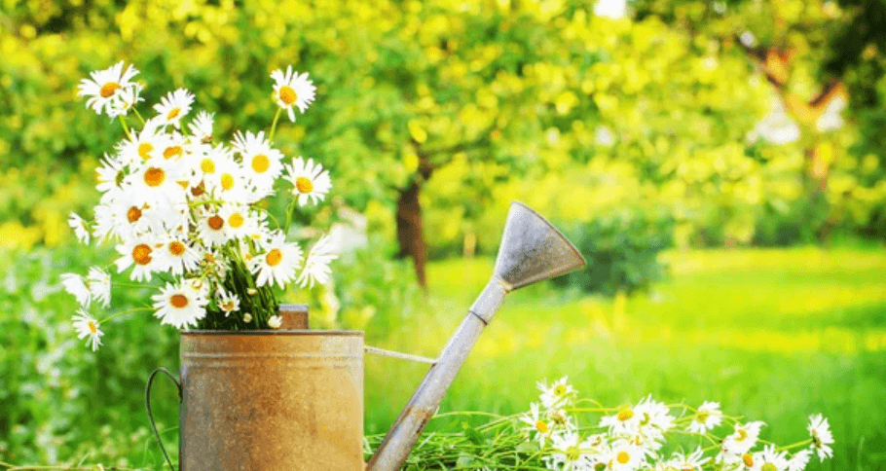
  Solution
  Test_solution
  Key Features
  Features test
  Unique Selling Point
  112
  1221
  23323424212

Competitor Analysis
On one lovely evening, a young boy was laughing and playing in the garden. He was chasing butterflies as he ran across the beautiful flowers. He also saw a bulky cow who was trying to keep a bug away by swirling her tail. The boy saw different animals like frogs, fish, etc. The child laughed and enjoyed the whole scene a lot. He then saw a small brown squirrel running here and there, he tried to follow it and reached a flower bed. It had beautiful red roses, the boy tried to pick one flower but the thorns plugged his finger. He ran to his mother crying and told her about everything. Listening to this his mother explained that we must not put any sort of harm to nature instead we should help it to grow. The boy learned a new lesson and was very happy.
Competitors | What they do well? | What they do badly?
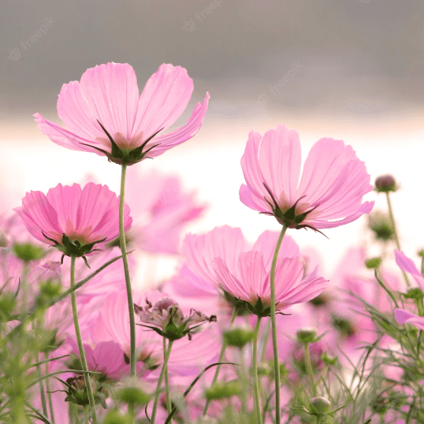  New company | Everything | Nothing

 | Customer Relationships |  | On one lovely evening, a young boy was laughing and playing in the garden. He was chasing butterflies as he ran across the beautiful flowers. He also saw a bulky cow who was trying to keep a bug away by swirling her tail. The boy saw different animals like frogs, fish, etc. The child laughed and enjoyed the whole scene a lot. He then saw a small brown squirrel running here and there, he tried to follow it and reached a flower bed. It had beautiful red roses, the boy tried to pick one flower but the thorns plugged his finger. He ran to his mother crying and told her about everything. Listening to this his mother explained that we must not put any sort of harm to nature instead we should help it to grow. The boy learned a new lesson and was very happy.
 |   Get |   Keep | Grow | Referrals

Get Name
How will you Get Customers?
Get Name
Explain Your Strategy
Explain this Get strategy. Why have you chosen it and why is it appropriate?Explain Your Strategy
Explain this Get strategy. Why have you chosen it and why is it appropriate?

 | Customer Relationships |  | On one lovely evening, a young boy was laughing and playing in the garden. He was chasing butterflies as he ran across the beautiful flowers. He also saw a bulky cow who was trying to keep a bug away by swirling her tail. The boy saw different animals like frogs, fish, etc. The child laughed and enjoyed the whole scene a lot. He then saw a small brown squirrel running here and there, he tried to follow it and reached a flower bed. It had beautiful red roses, the boy tried to pick one flower but the thorns plugged his finger. He ran to his mother crying and told her about everything. Listening to this his mother explained that we must not put any sort of harm to nature instead we should help it to grow. The boy learned a new lesson and was very happy.
 | Get | Keep | Grow | Referrals

Keep Name
How will you Keep Customers?
Keep Name
How will you Keep Customers?
Explain Your Strategy
Explain this Keep strategy. Why have you chosen it and why is it appropriate?xplain Your Strategy
Explain this Keep strategy. Why have you chosen it and why is it appropriate?xplain Your Strategy
Explain this Keep strategy. Why have you chosen it and why is it appropriate?

 | Customer Relationships |  | On one lovely evening, a young boy was laughing and playing in the garden. He was chasing butterflies as he ran across the beautiful flowers. He also saw a bulky cow who was trying to keep a bug away by swirling her tail. The boy saw different animals like frogs, fish, etc. The child laughed and enjoyed the whole scene a lot. He then saw a small brown squirrel running here and there, he tried to follow it and reached a flower bed. It had beautiful red roses, the boy tried to pick one flower but the thorns plugged his finger. He ran to his mother crying and told her about everything. Listening to this his mother explained that we must not put any sort of harm to nature instead we should help it to grow. The boy learned a new lesson and was very happy.
 | Get | Keep | Grow | Referrals

xplain Your Strategy
Explain this Keep strategy. Why have you chosen it and why is it appropriate?
xplain Your Strategy
Explain this Keep strategy. Why have you chosen it and why is it appropriate?xplain Your Strategy
Explain this Keep strategy. Why have you chosen it and why is it appropriate?xplain Your Strategy
Explain this Keep strategy. Why have you chosen it and why is it appropriate?

 | Customer Relationships |  | On one lovely evening, a young boy was laughing and playing in the garden. He was chasing butterflies as he ran across the beautiful flowers. He also saw a bulky cow who was trying to keep a bug away by swirling her tail. The boy saw different animals like frogs, fish, etc. The child laughed and enjoyed the whole scene a lot. He then saw a small brown squirrel running here and there, he tried to follow it and reached a flower bed. It had beautiful red roses, the boy tried to pick one flower but the thorns plugged his finger. He ran to his mother crying and told her about everything. Listening to this his mother explained that we must not put any sort of harm to nature instead we should help it to grow. The boy learned a new lesson and was very happy.
 | Get | Keep | Grow | Referrals

xplain Your Strategy
Explain this Keep strategy. Why have you chosen it and why is it appropriate?xplain Your Strategy
Explain this Keep strategy. Why have you chosen it and why is it appropriate?
xplain Your Strategy
Explain this Keep strategy. Why have you chosen it and why is it appropriate?xplain Your Strategy
Explain this Keep strategy. Why have you chosen it and why is it appropriate?xplain Your Strategy
Explain this Keep strategy. Why have you chosen it and why is it appropriate?

Channels
On one lovely evening, a young boy was laughing and playing in the garden. He was chasing butterflies as he ran across the beautiful flowers. He also saw a bulky cow who was trying to keep a bug away by swirling her tail. The boy saw different animals like frogs, fish, etc. The child laughed and enjoyed the whole scene a lot. He then saw a small brown squirrel running here and there, he tried to follow it and reached a flower bed. It had beautiful red roses, the boy tried to pick one flower but the thorns plugged his finger. He ran to his mother crying and told her about everything. Listening to this his mother explained that we must not put any sort of harm to nature instead we should help it to grow. The boy learned a new lesson and was very happy.
Explain Your Strategy
Explain this Keep strategy. Why have you chosen it and why is it appropriate?xplain Your Strategy
Explain this Keep strategy. Why have you chosen it and why is it appropriate?
Channel strategy
Explain Your Strategy
Explain this Keep strategy. Why have you chosen it and why is it appropriate?xplain Your Strategy
Explain this Keep strategy. Why have you chosen it and why is it appropriate?
Channel Strategy


  New_2
  Channel strategy
  Amidst the symphony of life, nature's canvas unfurls in breathtaking splendor. As the golden sun ascends the cerulean sky, its tender rays caress the Earth, coaxing dew-kissed petals to awaken from their slumber. The world awakens in a gentle, harmonious crescendo.

  Channel 3
  Channel strategy
  Majestic mountains, ancient sentinels of time, rise with regal grandeur, their peaks veiled in wisps of ethereal mist. They stand as silent witnesses to the eons, their rugged faces etched with tales of resilience and endurance.
  A tranquil river meanders through the heart of the forest, its crystalline waters murmuring secrets to the mossy stones that line its banks. It carries the whispers of the wilderness, a soothing lullaby to the creatures that call this sacred place home.

 | Feasibility |  | This beautiful passage is one of the simplest and most appealing short stories based on the environment. We, humans, are alive only because of our nature. Still, we continue to exploit it recklessly. We all must know the importance of mother nature and the consequences of troubling it. Therefore, this beautiful Nature story is one of the simplest ways to make kids understand the beauty and the power of nature. The story is about a young boy who got attracted to nature's beauty while playing in the garden and witnessed its power when he tried to change it. In the end, his mother beautifully explains everything about nature and its process. Given below is a summary of the story that will make the concepts more clear.This beautiful passage is one of the simplest and most appealing short stories based on the environment. We, humans, are alive only because of our nature. Still, we continue to exploit it recklessly. We all must know the importance of mother nature and the consequences of troubling it. Therefore, this beautiful Nature story is one of the simplest ways to make kids understand the beauty and the power of nature. The story is about a young boy who got attracted to nature's beauty while playing in the garden and witnessed its power when he tried to change it. In the end, his mother beautifully explains everything about nature and its process. Given below is a summary of the story that will make the concepts more clear.

Key Activities, Resources & Partners
This beautiful passage is one of the simplest and most appealing short stories based on the environment. We, humans, are alive only because of our nature. Still, we continue to exploit it recklessly. We all must know the importance of mother nature and the consequences of troubling it. Therefore, this beautiful Nature story is one of the simplest ways to make kids understand the beauty and the power of nature. The story is about a young boy who got attracted to nature's beauty while playing in the garden and witnessed its power when he tried to change it. In the end, his mother beautifully explains everything about nature and its process. Given below is a summary of the story that will make the concepts more clear.
Key Activities
 |  |  | Step 1  Add step 1 in your process  Step 1  Add step 1 in your process  Step 1  Add step 1 in your process
This a test
This a testThis a test
This a testThis a test
This a testThis a test
This a testThis a test

 |  | Key Resources

Key Resources
Create a list of the Key Resources required to run your businessKey Resources
Create a list of the Key Resources required to run your business
Key Resources
Create a list of the Key Resources required to run your businessKey Resources
Create a list of the Key Resources required to run your business
 |  | Key Partners

Add up to 6 Key Partners. Review your Key Activities below to help.Think about who you need to work with to successfully deliver these activities. Which will you do independently, and which will you need help to complete?
Your Key Activities are:
Step 1
Add up to 6 Key Partners. Review your Key Activities below to help.Think about who you need to work with to successfully deliver these activities. Which will you do independently, and which will you need help to complete?
Your Key Activities are:
Step 1

 | Viability |  | This beautiful passage is one of the simplest and most appealing short stories based on the environment. We, humans, are alive only because of our nature. Still, we continue to exploit it recklessly. We all must know the importance of mother nature and the consequences of troubling it. Therefore, this beautiful Nature story is one of the simplest ways to make kids understand the beauty and the power of nature. The story is about a young boy who got attracted to nature's beauty while playing in the garden and witnessed its power when he tried to change it. In the end, his mother beautifully explains everything about nature and its process. Given below is a summary of the story that will make the concepts more clear.

Finance
This beautiful passage is one of the simplest and most appealing short stories based on the environment. We, humans, are alive only because of our nature. Still, we continue to exploit it recklessly. We all must know the importance of mother nature and the consequences of troubling it. Therefore, this beautiful Nature story is one of the simplest ways to make kids understand the beauty and the power of nature. The story is about a young boy who got attracted to nature's beauty while playing in the garden and witnessed its power when he tried to change it. In the end, his mother beautifully explains everything about nature and its process. Given below is a summary of the story that will make the concepts more clear.
REVENUE STRATEGY
12
12Revenue ModelRevenue Model
12
22Revenue ModelRevenue ModelRevenue Model
14
Revenue ModelRevenue Model12 Revenue Model

Revenue Strategy
Product Name | Unit | Unit cost | Sale price | Gross Profit | Gross Margin
test | 334 | 343434 | 12 | -343422.00 | -2861850%

FORECASTS
Cash In
 | MONTH 1 | MONTH 2 | MONTH 3 | MONTH 4 | MONTH 5 | MONTH 6 | MONTH 7 | MONTH 8 | MONTH 9 | MONTH 10 | MONTH 11 | MONTH 12
test | 0 | 0 | 0 | 0 | 0 | 0 | 0 | 0 | 0 | 0 | 0 | 0
Total Cash In | 0 | 0 | 0 | 0 | 0 | 0 | 0 | 0 | 0 | 0 | 0 | 0
Cash out
Fixed Cost | MONTH 1 | MONTH 2 | MONTH 3 | MONTH 4 | MONTH 5 | MONTH 6 | MONTH 7 | MONTH 8 | MONTH 9 | MONTH 10 | MONTH 11 | MONTH 12
rent | 13995 | 13995 | 13995 | 13995 | 13995 | 13995 | 13995 | 13995 | 13995 | 13995 | 13995 | 13995
Variable Cost
test | 0 | 0 | 0 | 0 | 0 | 0 | 0 | 0 | 0 | 0 | 0 | 0
Total Cash Out | 13995 | 13995 | 13995 | 13995 | 13995 | 13995 | 13995 | 13995 | 13995 | 13995 | 13995 | 13995
Balance
Monthly Cash In/Out | -13995 | -13995 | -13995 | -13995 | -13995 | -13995 | -13995 | -13995 | -13995 | -13995 | -13995 | -13995
Cumulative Balance | -13995 | -27990 | -41985 | -55980 | -69975 | -83970 | -97965 | -111960 | -125955 | -139950 | -153945 | -167940

GRAPH
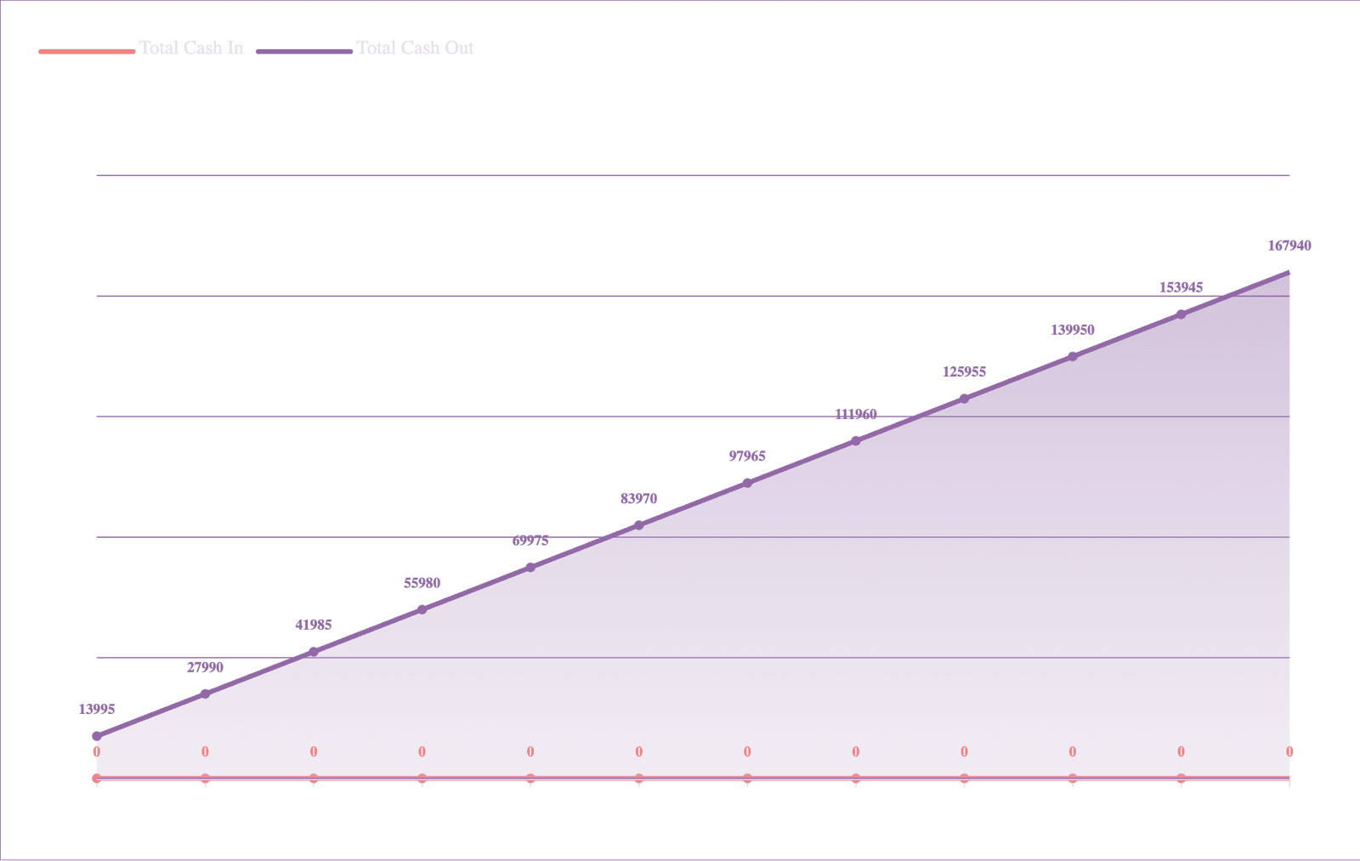

Sustainability
This beautiful passage is one of the simplest and most appealing short stories based on the environment. We, humans, are alive only because of our nature. Still, we continue to exploit it recklessly. We all must know the importance of mother nature and the consequences of troubling it. Therefore, this beautiful Nature story is one of the simplest ways to make kids understand the beauty and the power of nature. The story is about a young boy who got attracted to nature's beauty while playing in the garden and witnessed its power when he tried to change it. In the end, his mother beautifully explains everything about nature and its process. Given below is a summary of the story that will make the concepts more clear.This beautiful passage is one of the simplest and most appealing short stories based on the environment. We, humans, are alive only because of our nature. Still, we continue to exploit it recklessly. We all must know the importance of mother nature and the consequences of troubling it. Therefore, this beautiful Nature story is one of the simplest ways to make kids understand the beauty and the power of nature. The story is about a young boy who got attracted to nature's beauty while playing in the garden and witnessed its power when he tried to change it. In the end, his mother beautifully explains everything about nature and its process. Given below is a summary of the story that will make the concepts more clear.This beautiful passage is one of the simplest and most appealing short stories based on the environment. We, humans, are alive only because of our nature. Still, we continue to exploit it recklessly. We all must know the importance of mother nature and the consequences of troubling it. Therefore, this beautiful Nature story is one of the simplest ways to make kids understand the beauty and the power of nature. The story is about a young boy who got attracted to nature's beauty while playing in the garden and witnessed its power when he tried to change it. In the end, his mother beautifully explains everything about nature and its process. Given below is a summary of the story that will make the concepts more clear.This beautiful passage is one of the simplest and most appealing short stories based on the environment. We, humans, are alive only because of our nature. Still, we continue to exploit it recklessly. We all must know the importance of mother nature and the consequences of troubling it. Therefore, this beautiful Nature story is one of the simplest ways to make kids understand the beauty and the power of nature. The story is about a young boy who got attracted to nature's beauty while playing in the garden and witnessed its power when he tried to change it. In the end, his mother beautifully explains everything about nature and its process. Given below is a summary of the story that will make the concepts more clear.This beautiful passage is one of the simplest and most appealing short stories based on the environment. We, humans, are alive only because of our nature. Still, we continue to exploit it recklessly. We all must know the importance of mother nature and the consequences of troubling it. Therefore, this beautiful Nature story is one of the simplest ways to make kids understand the beauty and the power of nature. The story is about a young boy who got attracted to nature's beauty while playing in the garden and witnessed its power when he tried to change it. In the end, his mother beautifully explains everything about nature and its process. Given below is a summary of the story that will make the concepts more clear.This beautiful passage is one of the simplest and most appealing short stories based on the environment. We, humans, are alive only because of our nature. Still, we continue to exploit it recklessly. We all must know the importance of mother nature and the consequences of troubling it. Therefore, this beautiful Nature story is one of the simplest ways to make kids understand the beauty and the power of nature. The story is about a young boy who got attracted to nature's beauty while playing in the garden and witnessed its power when he tried to change it. In the end, his mother beautifully explains everything about nature and its process. Given below is a summary of the story that will make the concepts more clear.
 | 
  
  Sustainable Development Goal 3
  Quality Education
  
  Sustainable Development Goal 4
  Gender Equality
  Sustainable Development Goal 3
  Quality Education

Sustainable Development Goal 2
Good Health and Well Being

Sustainability
This beautiful passage is one of the simplest and most appealing short stories based on the environment. We, humans, are alive only because of our nature. Still, we continue to exploit it recklessly. We all must know the importance of mother nature and the consequences of troubling it. Therefore, this beautiful Nature story is one of the simplest ways to make kids understand the beauty and the power of nature. The story is about a young boy who got attracted to nature's beauty while playing in the garden and witnessed its power when he tried to change it. In the end, his mother beautifully explains everything about nature and its process. Given below is a summary of the story that will make the concepts more clear.This beautiful passage is one of the simplest and most appealing short stories based on the environment. We, humans, are alive only because of our nature. Still, we continue to exploit it recklessly. We all must know the importance of mother nature and the consequences of troubling it. Therefore, this beautiful Nature story is one of the simplest ways to make kids understand the beauty and the power of nature. The story is about a young boy who got attracted to nature's beauty while playing in the garden and witnessed its power when he tried to change it. In the end, his mother beautifully explains everything about nature and its process. Given below is a summary of the story that will make the concepts more clear.This beautiful passage is one of the simplest and most appealing short stories based on the environment. We, humans, are alive only because of our nature. Still, we continue to exploit it recklessly. We all must know the importance of mother nature and the consequences of troubling it. Therefore, this beautiful Nature story is one of the simplest ways to make kids understand the beauty and the power of nature. The story is about a young boy who got attracted to nature's beauty while playing in the garden and witnessed its power when he tried to change it. In the end, his mother beautifully explains everything about nature and its process. Given below is a summary of the story that will make the concepts more clear.This beautiful passage is one of the simplest and most appealing short stories based on the environment. We, humans, are alive only because of our nature. Still, we continue to exploit it recklessly. We all must know the importance of mother nature and the consequences of troubling it. Therefore, this beautiful Nature story is one of the simplest ways to make kids understand the beauty and the power of nature. The story is about a young boy who got attracted to nature's beauty while playing in the garden and witnessed its power when he tried to change it. In the end, his mother beautifully explains everything about nature and its process. Given below is a summary of the story that will make the concepts more clear.This beautiful passage is one of the simplest and most appealing short stories based on the environment. We, humans, are alive only because of our nature. Still, we continue to exploit it recklessly. We all must know the importance of mother nature and the consequences of troubling it. Therefore, this beautiful Nature story is one of the simplest ways to make kids understand the beauty and the power of nature. The story is about a young boy who got attracted to nature's beauty while playing in the garden and witnessed its power when he tried to change it. In the end, his mother beautifully explains everything about nature and its process. Given below is a summary of the story that will make the concepts more clear.This beautiful passage is one of the simplest and most appealing short stories based on the environment. We, humans, are alive only because of our nature. Still, we continue to exploit it recklessly. We all must know the importance of mother nature and the consequences of troubling it. Therefore, this beautiful Nature story is one of the simplest ways to make kids understand the beauty and the power of nature. The story is about a young boy who got attracted to nature's beauty while playing in the garden and witnessed its power when he tried to change it. In the end, his mother beautifully explains everything about nature and its process. Given below is a summary of the story that will make the concepts more clear.
SGD | Social/Environmental Problem | Social/Environmental Value
 | Social/Environmental Problem  What social/environmental problem are you tackling? | Social/Environmental Value  What social/environmental value will you create?
 | Social/Environmental Problem  What social/environmental problem are you tackling? | Social/Environmental Value  What social/environmental value will you create?
 | Social/Environmental Problem  What social/environmental problem are you tackling? | Social/Environmental Value  What social/environmental value will you create?
 | Social/Environmental Problem  What social/environmental problem are you tackling? | Social/Environmental Value  What social/environmental value will you create?

 | Contact us
 | Visual representation of The Nature story | Yuliia Test | yulia@test.com
 | Poems About Nature. All rights reserved |  | Build & Create on Validate

